桂林理工大学2022年非实名人员控制数工作人员公开招聘专任教师岗位试讲内容及要求

岗位名称 | 试讲内容及要求
教师01 | 试讲为10分钟讲课。试讲内容由考生自选本专业课程内容。
教师02 | 试讲为10分钟讲课。试讲内容由考生自选本专业课程内容。
教师03 | 试讲为10分钟讲课。试讲内容由考生在以下2项中任选1项：  1.《水利工程经济学》（第二版），方国华主编，中国水利水电出版社。  第五章：经济效果评价指标和评价方法；第一节：净现值法。  2.《环境地质学》（新一版），陈余道，蒋亚萍主编，中国水利水电出版社。  第九章：土壤与环境；第一节：土壤与土地。
教师04 | 试讲为10分钟说课。说课内容为：  《土木工程概论》，郑毅，熊瑞生主编，武汉理工大学出版社。  第一章：土木工程及土木工程专业；第一节：土木工程和土木工程专业。
教师05 | 试讲为10分钟说课。说课内容为：  《土木工程概论》，郑毅，熊瑞生主编，武汉理工大学出版社。  第一章：土木工程及土木工程专业；第一节：土木工程和土木工程专业。
教师06 | 试讲为10分钟讲课。试讲内容为：  《测绘工程学》，林文介主编，华南理工大学出版社。  第七章：地图与地形图应用。
教师07 | 试讲为10分钟讲课。试讲内容为：  《测绘工程学》，林文介主编，华南理工大学出版社。  第七章：地图与地形图应用。
教师08 | 试讲为10分钟讲课。试讲内容由考生在以下3项中任选1项：  1.《机械制图》（第7版）， 何铭新、钱可强、徐祖茂主编，高等教育出版社出版。  2.《机械制造技术基础》（第4版），卢秉恒主编，机械工业出版社出版。  3.《自动控制原理》，卢京潮主编，清华大学出版社出版。
教师09 | 试讲为10分钟说课。说课内容由考生自选本专业课程一节课内容。
教师10 | 试讲为10分钟说课。说课内容由考生自选本专业课程一节课内容。
教师11 | 试讲为10分钟讲课。试讲内容由考生自选本专业课程内容。
教师12 | 试讲为10分钟讲课。试讲内容由考生自选本专业课程内容。
教师13 | 试讲为10分钟讲课。试讲内容由考生自选本专业课程内容。
教师14 | 试讲为10分钟讲课。试讲内容由考生自选本专业课程内容。
教师15 | 试讲为10分钟讲课。试讲内容由考生自选本专业课程内容。
教师16 | 试讲为10分钟讲课。试讲内容由考生在以下2项中任选1项：  1.《社会学教程》（第五版），王思斌主编，北京大学出版社，2021年。  第六章：社会组织；第二节：组织目标与组织运行。  2. 《新闻学概论》（第七版），李良荣著，复旦大学出版社，2021年。  第十六章：新闻媒介的受众；第五节：新闻媒介的受众定位。
教师17 | 试讲为10分钟讲课。试讲内容和要求：  1.从《马克思主义基本原理》《毛泽东思想和中国特色社会主义理论体系概论》和《习近平新时代中国特色社会主义思想概论》中自选一个内容进行试讲。  2.教材使用马克思主义理论研究和建设工程统编教材（高校思想政治理论课2023年版）。  3.要求将党的二十大精神融入课程教学内容中。
教师18 | 试讲为10分钟讲课。试讲内容和要求：  1.从《马克思主义基本原理》《毛泽东思想和中国特色社会主义理论体系概论》和《习近平新时代中国特色社会主义思想概论》中自选一个内容进行试讲。  2.教材使用马克思主义理论研究和建设工程统编教材（高校思想政治理论课2023年版）。  3.要求将党的二十大精神融入课程教学内容中。
教师19 | 试讲为10分钟说课。全程使用英语，紧扣试讲材料内容开展说课。  试讲材料：  New research: accepting negative emotions is better for health  New research indicates that people who habitually accept their negative emotions experience fewer negative emotions, which adds up to better psychological health. By contrast, pressure to feel upbeat can make people feel downbeat.  In findings published in the Journal of Personality and Social Psychology, researchers tested the link between emotional acceptance and psychological health in more than 1,300 adults in the San Francisco Bay Area and the Denver, Colorado, metropolitan area. The results suggest that people who commonly resist acknowledging their darkest emotions, or judge them harshly, can end up feeling more psychologically stressed, and those who generally allow such bleak feelings as sadness, disappointment and resentment to run their course reported fewer mood disorder symptoms than those who critique them or push them away, even after six months.  Three separate studies were conducted at the University of California, Berkeley, on various groups both in the lab and online, and factored in age, gender, socio-economic status and other demographic variables, according to a news release from UC Berkeley on Thursday. In the first study, more than 1,000 participants filled out surveys rating how strongly they agreed with such statements as “I tell myself I shouldn't be feeling the way that I'm feeling.” Those who, as a rule, did not feel bad about feeling bad showed higher levels of well-being than their less accepting peers.  Then, in a laboratory setting, more than 150 participants were tasked with delivering a three-minute videotaped speech to a panel of judges as part of a mock job application, touting their communication skills and other relevant qualifications. They were given two minutes to prepare. After completing the task, participants rated their emotions about the ordeal. As expected, the group that typically avoids negative feelings reported more distress than their more accepting peers.  In the final study, more than 200 people journaled about their most taxing experiences over a two-week period. When surveyed about their psychological health six months later, the diarists who typically avoided negative emotions reported more mood disorder symptoms than their nonjudgmental peers.  At this point, the researchers, including lead author Brett Ford, an assistant professor of psychology at the University of Toronto, Canada, and senior author Iris Mauss, an associate professor of psychology at UC Berkeley, can only speculate on why people accepting joyless emotions can defuse them, like dark clouds passing swiftly in front of the sun and out of sight. Next, they plan to look into such factors as culture and upbringing to better understand why some people are more accepting of emotional ups and downs than others.
教师20 | 试讲为10分钟说课。说课内容由考生在以下2项中任选1项：  1.全程使用英语，紧扣试讲材料内容开展说课。  试讲材料：  New research: accepting negative emotions is better for health  New research indicates that people who habitually accept their negative emotions experience fewer negative emotions, which adds up to better psychological health. By contrast, pressure to feel upbeat can make people feel downbeat.  In findings published in the Journal of Personality and Social Psychology, researchers tested the link between emotional acceptance and psychological health in more than 1,300 adults in the San Francisco Bay Area and the Denver, Colorado, metropolitan area. The results suggest that people who commonly resist acknowledging their darkest emotions, or judge them harshly, can end up feeling more psychologically stressed, and those who generally allow such bleak feelings as sadness, disappointment and resentment to run their course reported fewer mood disorder symptoms than those who critique them or push them away, even after six months.  Three separate studies were conducted at the University of California, Berkeley, on various groups both in the lab and online, and factored in age, gender, socio-economic status and other demographic variables, according to a news release from UC Berkeley on Thursday. In the first study, more than 1,000 participants filled out surveys rating how strongly they agreed with such statements as “I tell myself I shouldn't be feeling the way that I'm feeling.” Those who, as a rule, did not feel bad about feeling bad showed higher levels of well-being than their less accepting peers.  Then, in a laboratory setting, more than 150 participants were tasked with delivering a three-minute videotaped speech to a panel of judges as part of a mock job application, touting their communication skills and other relevant qualifications. They were given two minutes to prepare. After completing the task, participants rated their emotions about the ordeal. As expected, the group that typically avoids negative feelings reported more distress than their more accepting peers.  In the final study, more than 200 people journaled about their most taxing experiences over a two-week period. When surveyed about their psychological health six months later, the diarists who typically avoided negative emotions reported more mood disorder symptoms than their nonjudgmental peers.  At this point, the researchers, including lead author Brett Ford, an assistant professor of psychology at the University of Toronto, Canada, and senior author Iris Mauss, an associate professor of psychology at UC Berkeley, can only speculate on why people accepting joyless emotions can defuse them, like dark clouds passing swiftly in front of the sun and out of sight. Next, they plan to look into such factors as culture and upbringing to better understand why some people are more accepting of emotional ups and downs than others.  2.全程使用法语，紧扣试讲材料内容开展说课。  试讲材料：  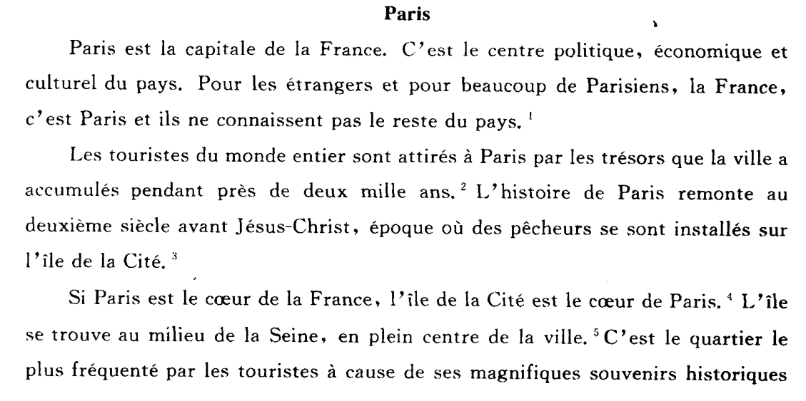  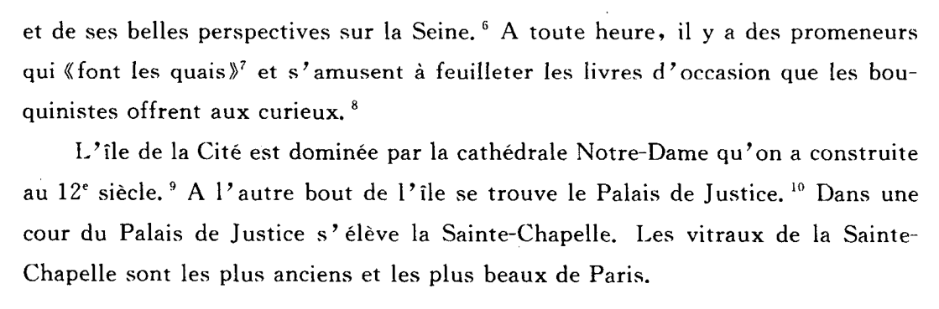
教师21 | 试讲为10分钟讲课。试讲内容由考生自选本专业课程内容。
教师22 | 试讲为10分钟讲课。试讲内容由考生自选本专业课程内容。
教师23 | 试讲为10分钟讲课。试讲内容由考生在以下9项中任选1项：  1.《中国传统音乐概论》主编：袁静芳 上海音乐出版社。  第一章 民间歌曲 第二节 民间歌曲的类别与艺术特征 一、汉族民歌  2.《世界民族音乐》 主编：王耀华、王州 人民教育出版社。  第一章 东亚音乐 第二节 主要音乐体裁、乐器及其音乐 三、蒙古的传统音乐体裁与乐器  3. 《音乐欣赏》（第3版）高等院校人文素质教育课程规划教材 主编：卢广瑞 清华大学出版社。  第三章 古典主义和浪漫主义音乐体裁欣赏 第二节 序曲音乐欣赏  4. 《外国舞蹈史及作品鉴赏》主编：欧建平 高等教育出版社。  第五章 芭蕾（三） 第一节 古典芭蕾  5. 《中国民间舞蹈文化教程》主编：罗雄岩 上海音乐出版社。  第八章 草原文化与游牧民族民间舞蹈 第二节 蒙古族民间舞蹈  6. 《中外舞蹈鉴赏语言》主编：黄小明 广西师范大学出版社。  第一讲 灵动的语言——舞蹈的特征与要素  7. 《大学语文》：加缪在《西西弗斯神话》中的荒诞哲学发挥。  8. 《大学语文》：《张中丞传后叙》的夹叙夹议手法。  9. 《大学语文》：小说《伤逝》中子君和涓生人物形象分析。
教师24 | 试讲为10分钟讲课。试讲内容由考生在以下9项中任选1项：  1.《中国传统音乐概论》主编：袁静芳 上海音乐出版社。  第一章 民间歌曲 第二节 民间歌曲的类别与艺术特征 一、汉族民歌  2.《世界民族音乐》 主编：王耀华、王州 人民教育出版社。  第一章 东亚音乐 第二节 主要音乐体裁、乐器及其音乐 三、蒙古的传统音乐体裁与乐器  3. 《音乐欣赏》（第3版）高等院校人文素质教育课程规划教材 主编：卢广瑞 清华大学出版社。  第三章 古典主义和浪漫主义音乐体裁欣赏 第二节 序曲音乐欣赏  4. 《外国舞蹈史及作品鉴赏》主编：欧建平 高等教育出版社。  第五章 芭蕾（三） 第一节 古典芭蕾  5. 《中国民间舞蹈文化教程》主编：罗雄岩 上海音乐出版社。  第八章 草原文化与游牧民族民间舞蹈 第二节 蒙古族民间舞蹈  6. 《中外舞蹈鉴赏语言》主编：黄小明 广西师范大学出版社。  第一讲 灵动的语言——舞蹈的特征与要素  7. 《大学语文》：加缪在《西西弗斯神话》中的荒诞哲学发挥。  8. 《大学语文》：《张中丞传后叙》的夹叙夹议手法。  9. 《大学语文》：小说《伤逝》中子君和涓生人物形象分析。
教师25 | 试讲为10分钟讲课。试讲内容由考生自选本专业课程内容。
教师26 | 试讲为10分钟讲课。试讲内容由考生自选本专业课程内容。

